USH+ Name: Quang Huynh

Lincoln-Douglas Debates

**Part I:** with your partners, discuss and list your answers to the chart below

|  |  |  |  |
| --- | --- | --- | --- |
| What did each group below think about the subjects to the right? | **Morality of Slavery** | **Legitimacy of Slavery under the U.S. Constitution** | **Economics of Slavery** |
| **Slavery’s Opponents** | Slaves should be treated like human beings and not like property. | If it is not in the constitution, then it should not be a thing in the United States. There should be some equality to all humans. |  |
| **Slavery’s Defenders** | Slave owners did not view slavery as morally incorrect because they saw slaves as property instead of an individual. There was a lot of slavery in the Bible. | Officially, slavery was not mentioned in the Constitution and so slaves were not seen as property to the government. This means they were able to receive the benefits and protections of a citizen. Supreme Court says black people have no rights. | Slavery helped with the economy of the United States. Slavery helped with doing labor for wealthy and it was very profitable. The end of slavery would kill the economy in the South. |

**Part II:** as a group, complete a BLOCK for the Short Essay Set #1 below. We have already discussed in class what the block entails, review your notes for a refresher. In the bottom half of the block, your group must determine **cause**, **effect**, **similarity**, **difference**, or **turning point** before making your notes.

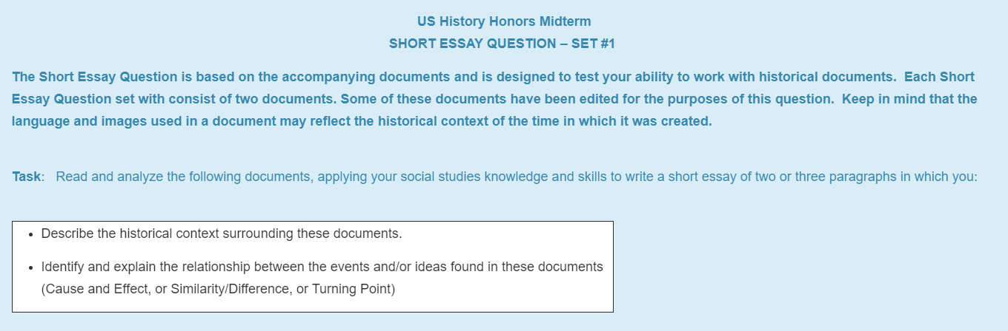

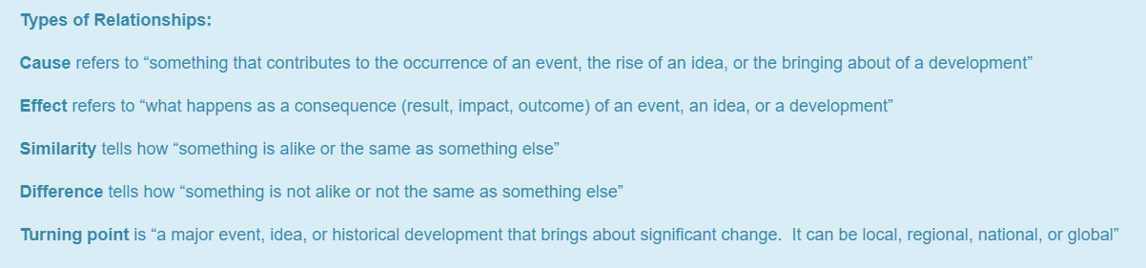

**Document 1:**

Mr. President and Gentlemen of the Convention.

If we could first know where we are, and whither we are tending, we could then better judge what to do, and how to do it. We are now far into the fifth year, since a policy was initiated, with the avowed object, and confident promise, of putting an end to slavery agitation. Under the operation of that policy, that agitation has not only, not ceased, but has constantly augmented. In my opinion, it will not cease, until a crisis shall have been reached, and passed. "A house divided against itself cannot stand." I believe this government cannot endure, permanently half slave and half free. I do not expect the Union to be dissolved -- I do not expect the house to fall -- but I do expect it will cease to be divided. It will become all one thing or all the other. Either the opponents of slavery, will arrest the further spread of it, and place it where the public mind shall rest in the belief that it is in the course of ultimate extinction; or its advocates will push it forward, till it shall become alike lawful in all the States, old as well as new -- North as well as South.

**Source: A. Lincoln, Illinois Republican State Convention, June 16, 1858**

**Document 2:**

I am delighted to hear you Black Republicans say "good." I have no doubt that doctrine expresses your sentiments and I will prove to you now, if you will listen to me, that it is revolutionary and destructive of the existence of this Government. Mr. Lincoln, in the extract from which I have read, says that this Government cannot endure permanently in the same condition in which it was made by its framers-divided into free and slave States. He says that it has existed for about seventy years thus divided, and yet he tells you that it cannot endure permanently on the same principles and in the same relative condition in which our fathers made it. Why can it not exist divided into free and slave States? Washington, Jefferson, Franklin, Madison, Hamilton, Jay, and the great men of that day, made this Government divided into free States and slave States, and left each State perfectly free to do as it pleased on the subject of slavery. Why can it not exist on the same principles on which our fathers made it? They knew when they framed the Constitution that in a country as wide and broad as this, with such a variety of climate, production and interest, the people necessarily required different laws and institutions in different localities. They knew that the laws and regulations which would suit the granite hills of New Hampshire would be unsuited to the rice plantations of South Carolina, and they, therefore, provided that each State should retain its own Legislature and its own sovereignty, with the full and complete power to do as it pleased within its own limits, in all that was local and not national. One of the reserved rights of the States, was the right to regulate the relations between Master and Servant, on the slavery question. At the time the Constitution was framed, there were thirteen States in the Union, twelve of which were slaveholding States and one free State. Suppose this doctrine of uniformity preached by Mr. Lincoln, that the States should all be free or all be slave had prevailed, and what would have been the result? Of course, the twelve slaveholding States would have overruled the one free State, and slavery would have been fastened by a Constitutional provision on every inch of the American Republic, instead of being left as our fathers wisely left it, to each State to decide for itself. Here I assert that uniformity in the local laws and institutions of the different States in neither possible or desirable. If uniformity had been adopted when the Government was established, it must inevitably have been the uniformity of slavery everywhere, or else the uniformity of negro citizenship and negro equality everywhere.

**Source - S. Douglas, Ottawa, Illinois, August 21, 1858**